**Sourcecode:**

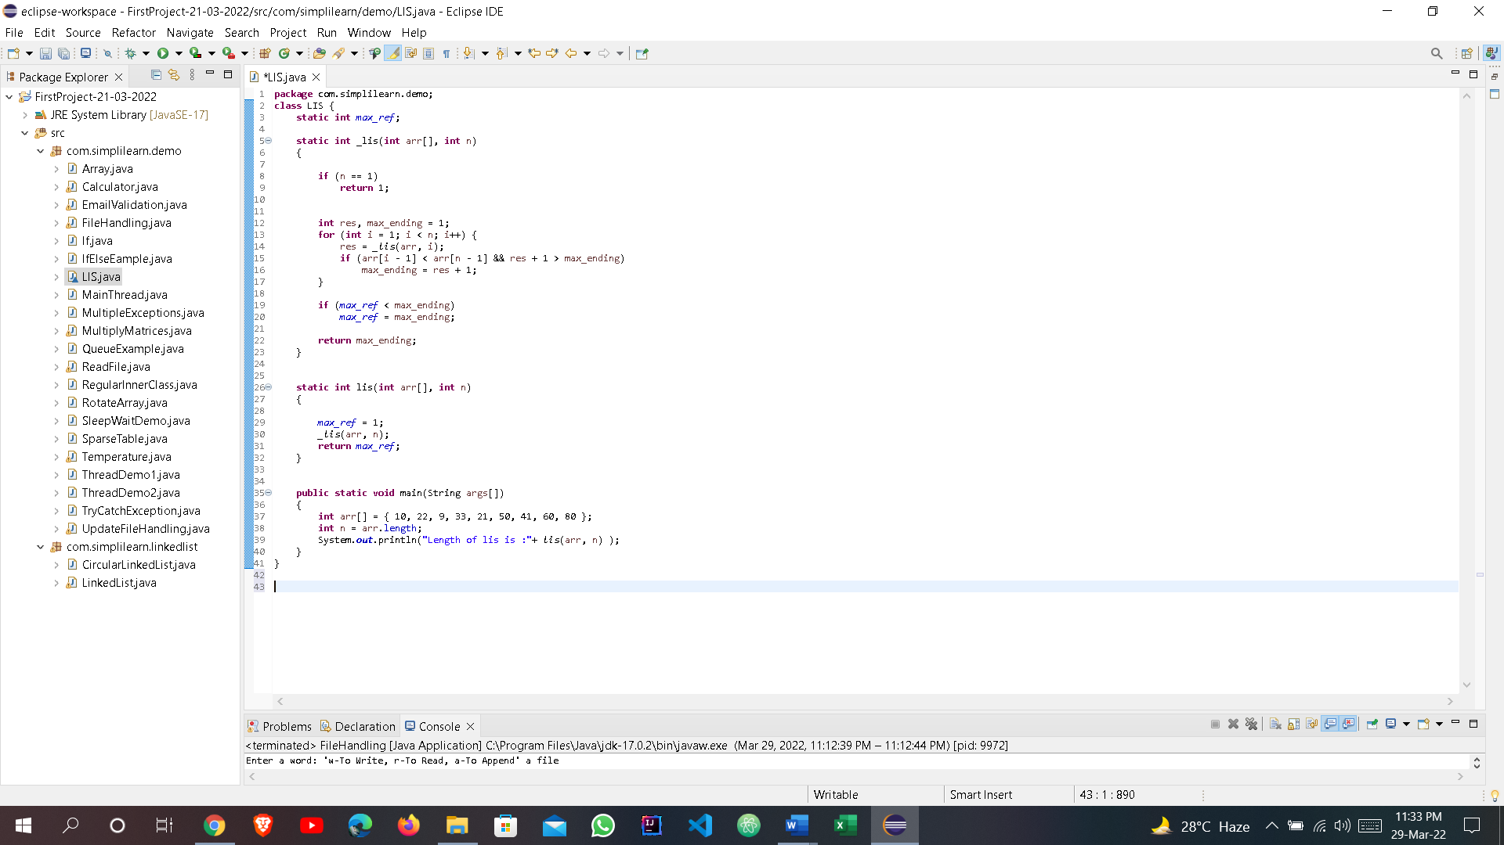

**Output:**

**When the array is { 10, 22, 9, 33, 21, 50, 41, 60, 80 }:**

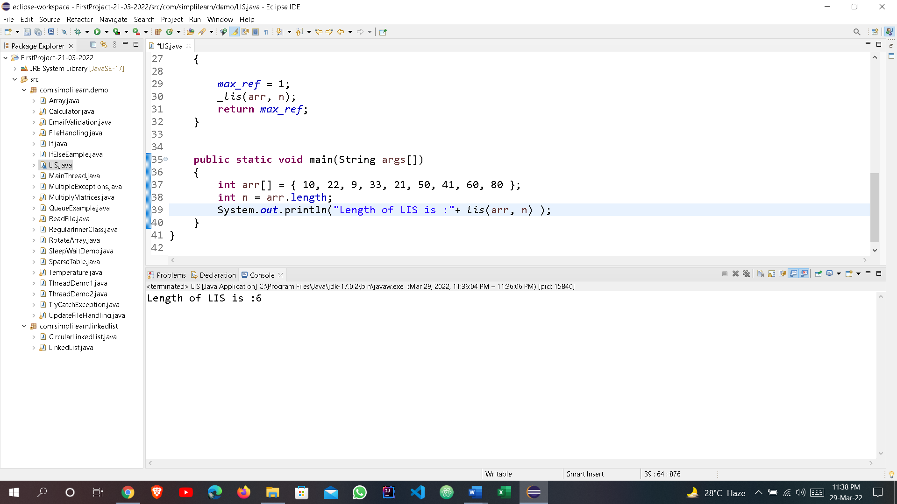

**When the array is { 60, 18, 29, 43, 11, 70, 51, 10, 90 }:**

